VISVESVARAYA TECHNOLOGICAL UNIVERSITY
“JNANA SANGAMA”, BELAGAVI -590 018.
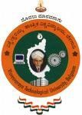
2025 – 2026
An Internship Report on
“Generative AI Intern”
Submitted in partial fulfillment for the award of the degree of BACHELOR OF ENGINEERING
in

Department of Information Science and Engineering

Submitted By

T J SHASHANK [1JB22IS164]

Under the guidance of

Mrs. Gayathri S
Assistant Professor,
Dept. of ISE
Jacob Dennis P
Trainee, CampusPe


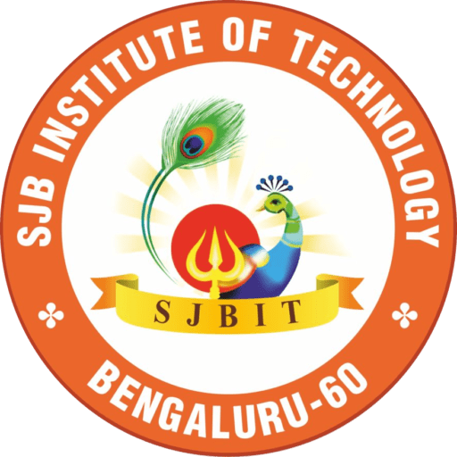

DEPARTMENT OF INFORMATION SCIENCE AND ENGINEERING

SJB INSTITUTE OF TECHNOLOGY
No. 67, BGS Health & Education City, Dr. Vishnuvardhan Road, Kengeri, Bengaluru - 560 060

2024 - 2025

||Jai Sri Gurudev||
Sri Adichunchanagiri Shikshana Trust ®
SJB INSTITUTE OF TECHNOLOGY
No. 67, BGS Health & Education City, Dr. Vishnuvardhan Road, Kengeri, Bengaluru - 560 060
An Autonomous Institute under VTU
Approved by AICTE - New Delhi, Accredited by NAAC A+, Accredited by NBA

DEPARTMENT OF INFORMATION SCIENCE AND ENGINEERING


CERTIFICATE

Certified that the internship work entitled “Generative AI Intern” is carried out by [T J Shashank] (1JB22IS164 ), a bonafide student of SJB Institute of Technology in partial fulfilment for the award of “BACHELOR OF ENGINEERING” in DEPARTMENT OF ISE as prescribed by VISVESVARAYA TECHNOLOGICAL UNIVERSITY, BELAGAVI during the academic
year 2025 - 26. It is further certified that all corrections/suggestions indicated for internal assessment have been incorporated in the report deposited in the departmental library. The internship report has been duly approved as it satisfies the academic requirements for the internship as prescribed for the said degree.

Prof Gayathri Dr Gopalakrishna M T Dr K V Mahendra Prashanth
Assistant Professor Professor & Head Principal
Dept. of ISE, SJBIT Dept. of ISE, SJBIT SJBIT

EXTERNAL VIVA-VOCE

Name of Examiners Signature with Date
1.

2.

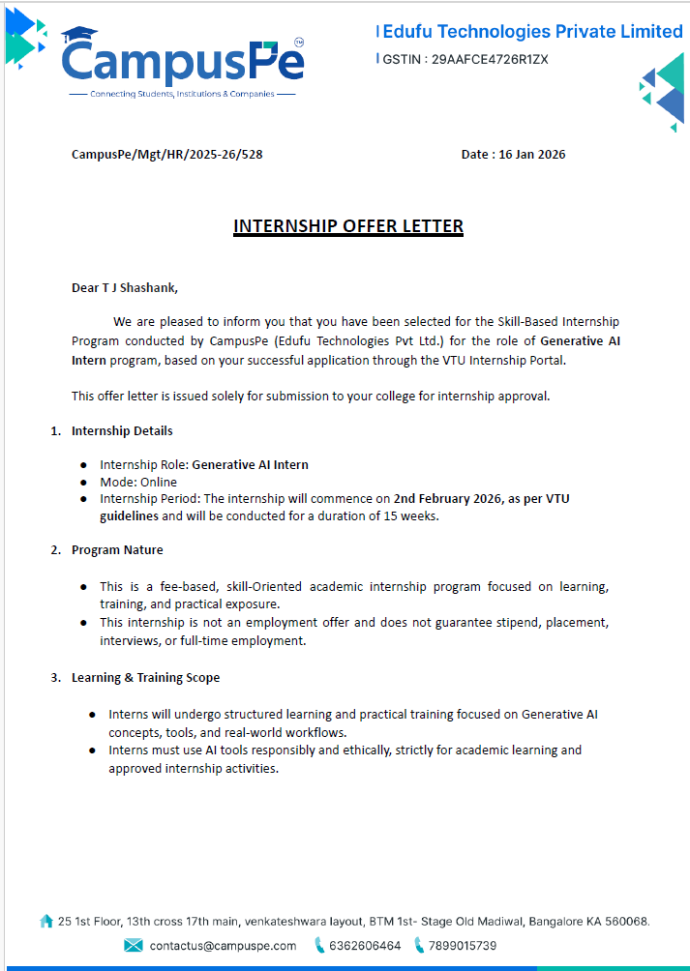

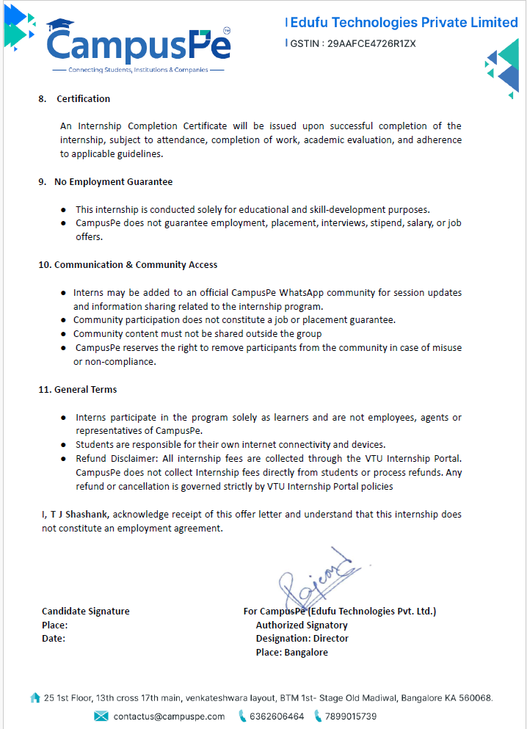

Certificate by the industry/company/organization





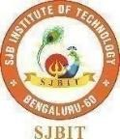
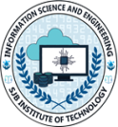
ACKNOWLEDGEMENT

I would like to express my profound gratitude to His Divine Soul Jagadguru PadmaBhushan Sri Sri Sri Dr. Balagangadharanatha Mahaswamiji and His Holiness Jagadguru Sri Sri Sri Dr. Nirmalanandanatha Swamiji for providing us an opportunity to be a part of this esteemed institution.
I would also like to express my sincere thanks to Revered Sri Sri Dr. Prakashnath Swamiji, Managing Director of SJB Institute of Technology, for his continuous support in providing the necessary support to by this esteemed institution.
I express our heartfelt gratitude to Dr. Puttaraju, Academic Director of the BGS & SJB Group of Institutions, Dr. K.V.Mahendra Prashanth, Principal of SJB Institute of Technology, Dr Babu N V, Academic Dean of SJB Institute of Technology and Dr. Gopalakrishna M.T, Professor & Head of the Department of Information Science & Engineering for providing me with their unwavering support, state-of-the-art facilities, and the enriching academic environment, which were instrumental in the successful completion of my Internship.
I extend my heartfelt gratitude to all the Deans of SJB Institute of Technology for their unwavering support, cutting-edge facilities, and the inspiring academic environment, all of which played a pivotal role in the successful completion of my internship.
I wish to express my heartfelt gratitude to my guide, Mrs Gayathri Assistant Professor for her valuable guidance, suggestions, and encouragement during the entire period of my internship.
I extend my sincere thanks to CampusPe for providing me with the opportunity to undertake internship and gain valuable industry experience. I am grateful for the supportive and professional environment, which has contributed immensely in learning and skill development.
I express my truthful thanks to Internship coordinators, Dept. of Information Science & Engineering for their valuable support.
Finally, I take this opportunity to extend my earnest gratitude and respect to our parents, the teaching & technical staff of the department, the library staff, and all my friends, who have directly or indirectly supported me during the period of my internship.

Regards,
T J Shashank [1JB22IS164]

 | ||Jai Sri Gurudev||  Sri Adichunchanagiri Shikshana Trust ®  SJB INSTITUTE OF TECHNOLOGY  No. 67, BGS Health & Education City, Dr. Vishnuvardhan Road, Kengeri, Bengaluru - 560 060  An Autonomous Institute under VTU  Approved by AICTE - New Delhi, Accredited by NAAC A+, Accredited by NBA

DEPARTMENT OF INFORMATION SCIENCE AND ENGINEERING

DECLARATION

I hereby declare that the entire work embodied in this internship report has been carried out under the supervision of <Mrs Gayathri S Assistant Professor> in partial fulfilment for the award of “BACHELOR OF ENGINEERING” in Dept. of Information Science and Engineering as prescribed by Visvesvaraya Technological University, Belagavi during the academic year 2025 – 26.

T J Shashank [1JB22IS164] Signature

Executive Summary

This internship was a comprehensive learning experience that focused on Artificial Intelligence, backend development, and real-world software project implementation. I worked as an AI Developer, where my primary responsibility was to design and integrate AI-based functionalities into a web application. During the initial phase of the internship, I gained strong foundational knowledge in Python programming, prompt engineering, REST APIs, and version control using Git. I also learned how different AI tools can be used effectively for solving real-world problems. In the later phase, I worked on a capstone project titled “Data Retention and Disposal Manager (Tool-51)”, which is an AI-powered web application designed to analyze data and provide intelligent recommendations. My contributions included developing AI endpoints, designing prompt templates, integrating APIs, and improving system performance.Overall, the internship enhanced my technical skills, problem-solving abilities, and understanding of real-world software development practice. This internship helped me strengthen both technical and problem-solving skills while gaining real-world development experience
Table of Contents

Chapter No | Particulars | Page
Acknowledgement |  | i
Declaration |  | ii
Executive Summary |  | iii
Table of contents |  | iv
List of figures |  | v
List of tables |  | v
1 | Introduction | 1-2
2 | About the Organization | 3-6
3 | Objectives of Internship | 7-9
4 | Internship Activities and Tasks | 10-12
5 | Learning Experiences | 13-15
6 | Learning Outcomes | 16-
7 | Reflection and Analysis
8 | Conclusion/Summary
9 | Reference
10 | Appendices (If applicable)

List of figures

Figure | Particulars | Page

List of Tables

Table | Particulars | Page

Internship Title 2025-26

Chapter 1

Introduction

  - Objectives of the Internship.

- The internship provided hands-on experience in applying Artificial Intelligence concepts to real-world problems. It helped bridge the gap between theoretical knowledge and practical implementation through working models and applications.
- Exposure was gained to different phases of the software development lifecycle, including requirement analysis, design, development, testing, and deployment. This helped in understanding how industry-level projects are planned and executed.
- The internship strengthened programming proficiency in Python through regular coding tasks and backend development activities. Emphasis was placed on writing clean, efficient, and optimized code following industry standards.
- The internship offered practical knowledge of designing, developing, and consuming APIs. It also involved integrating third-party services, enabling smooth communication between different software components.
- By working on real project challenges, analytical skills were sharpened to identify issues and implement effective solutions. The internship encouraged logical thinking and a structured approach to problem resolution.
- The internship environment promoted collaboration through team discussions, reviews, and meetings. It improved professional communication skills and the ability to work effectively as part of a team.

1.2 Overview of the Organization

CampusPe is a technology-driven learning and internship platform designed to equip students with industry-relevant skills through practical training. The organization focuses on bridging the gap between academic learning and real-world application by emphasizing hands-on experience alongside conceptual understanding. Its approach ensures that students are better prepared to meet current industry expectations.

Internship Title 2025-26

The platform offers well-structured internship programs across domains such as Artificial Intelligence, Full Stack Development, and Software Engineering. These programs are designed with a strong focus on project-based learning, where students work on real-world problem statements under the guidance of experienced mentors. Continuous evaluation, feedback sessions, and milestone-based progress tracking help ensure consistent skill development.
CampusPe also emphasizes exposure to modern tools, frameworks, and development workflows commonly used in the industry. By simulating real workplace environments, including teamwork, deadlines, and regular reviews, the organization plays a significant role in shaping students into job-ready professionals. This practical exposure enhances both technical proficiency and professional confidence.
1.3 Internship Role / Position
I was officially assigned the position of Generative AI Intern; however, within the project, my role was designated as AI Developer (AI Developer 1). This role primarily focused on developing and integrating intelligent, AI-driven functionalities into the system. The responsibilities required hands-on involvement in designing, implementing, and optimizing AI components as part of the overall backend architecture.
As an AI Developer on the project, I was responsible for designing prompt templates for Generative AI models to ensure accurate, relevant, and context-aware responses. This involved prompt engineering techniques such as refining input structure, handling edge cases, and improving output consistency based on project requirements. I also worked on developing AI services using Flask, where AI logic was encapsulated into modular services. These services were exposed through RESTful API endpoints, enabling seamless interaction between the AI module and other backend components of the system. Another key responsibility was integrating AI APIs with backend systems, ensuring smooth data flow between the AI services and application layers. This included handling request validation, response formatting, and maintaining system reliability during API interactions.
Overall, this role allowed me to gain practical exposure to Generative AI development in a real-world project environment, while strengthening my skills in backend integration, API design, and intelligent system development.

Internship Title 2025-26

Chapter 2

ABOUT THE ORGANIZATION

2.1 Organization Overview
CampusPe is a private Educational Technology (EdTech) platform operating in India. The organization works in the intersection of education, technology, and career readiness, focusing on improving students’ employability through practical exposure and industry-aligned learning. CampusPe operates primarily from Bangalore, Karnataka, and delivers its services digitally across India, making its learning programs accessible to students from diverse geographic and academic backgrounds. The organization follows a startup model, emphasizing innovation, agility, and technology-driven solutions in education.
CampusPe was founded with the vision of simplifying and modernizing education-to-career pathways for students. The organization was created to address a significant gap in traditional education systems—where students gain theoretical knowledge but often lack real-world skills and hands-on experience required by industry. To solve this problem, CampusPe introduced internship-based, project-oriented learning programs that simulate industry workflows. Over time, the platform expanded its focus to include Artificial Intelligence, Software Development, Full Stack Engineering, and emerging technologies, aligning its offerings with current industry demands.
CampusPe adopts a practical, project-based learning approach, where students work on real-time projects under guided mentorship. The organization emphasizes learning by doing, enabling participants to apply concepts through hands-on implementation rather than only theoretical study.The platform also integrates modern tools, industry practices, and structured evaluations, helping students gain exposure to professional environments. Through internships, mentorship, and continuous feedback, CampusPe plays an important role in preparing students for real-world job roles and industry expectations.

Internship Title 2025-26

2.2 Vision, Mission, and Objectives
- Vision:
To become India's most trusted education and career platform, empowering millions of students to achieve their academic and professional aspirations while helping institutions and companies find the best talent efficiently.
- Mission:
To bridge the gap between talent and opportunity by providing a unified platform that simplifies college admissions, streamlines campus placements, and connects students with their dream careers through innovative technology and AI-powered solutions.
- Objective:
- Industry-Relevant Skill Development: To equip students with practical, job-ready skills through hands-on projects, internships, and real-time problem-solving experiences aligned with industry needs.
- Internship-Based and Project-Oriented Learning: To promote experiential learning by offering structured internship programs where students work on real-world projects under professional mentorship.
- Use of Technology and AI in Education: To utilize Artificial Intelligence and modern digital platforms to enhance learning, streamline access to opportunities, and improve the overall education-to-employment journey for students.
- Bridging Academia and Industry: To create strong connections between students, colleges, and employers by exposing learners to industry workflows, tools, and professional environments.

2.3 Products and Services

CampusPe offers a range of technology-driven educational and career support services designed to enhance students’ practical skills and employability.

Internship Title 2025-26

- Internship Programs in AI and Software Development: CampusPe provides structured, internship-based learning programs in domains such as Artificial Intelligence, Software Development, and related technologies. These internships focus on hands-on implementation, allowing students to work on real-world problem statements while applying theoretical concepts in practice.
- Capstone and Live Projects: The platform offers capstone projects and live industry-simulated projects that replicate real development environments. Students are required to design, develop, test, and optimize solutions, which helps them understand professional workflows, project documentation, and deployment practices.
- Training Sessions and Mentorship: CampusPe provides guided training sessions led by mentors and industry professionals. These sessions focus on technical concepts, tool usage, best practices, and problem-solving approaches. Continuous mentorship ensures that learners receive feedback, guidance, and performance evaluation throughout their learning journey.
2.4 Organizational Structure:
- CampusPe follows a collaborative and project‑oriented organizational structure that supports effective learning, mentorship, and professional development. The structure is designed to simulate real industry work environments, enabling interns to gain practical exposure while working in coordinated teams.
- Mentors: Mentors play a crucial role in guiding interns throughout the internship program. They provide technical expertise, review project progress, clarify concepts, and offer constructive feedback.
- Project Teams: Project Teams Interns are organized into project teams, each assigned to specific projects or modules. These teams typically consist of members working in different roles such as AI development, backend development, and frontend development.
- Role in the Organization: I worked as part of the AI Development Team, where I collaborated closely with backend and frontend developers. My role involved contributing to the AI components of the project while coordinating with other teams to ensure seamless integration of AI functionalities into the overall system.

Internship Title 2025-26

2.5 Work Environment and Culture
The work environment at CampusPe is structured to simulate a high-growth startup atmosphere, prioritizing agility, continuous skill acquisition, and professional accountability. The culture is built on the following pillars:
- Collaborative Ecosystem:
• Peer-to-Peer Interaction: The environment encourages cross-team collaboration. As an AI Developer 1, I frequently engaged in "knowledge-sharing" sessions with frontend and backend peers to ensure that AI service integrations (like the Groq API) aligned with the overall system architecture.
• Mentorship Accessibility: Mentors act as facilitators rather than traditional supervisors. The culture promotes Open Communication, allowing interns to seek guidance on complex debugging issues or architectural bottlenecks without hesitation.
- Pedagogy: Learning by Doing
• Applied Knowledge: Instead of theoretical training, the culture emphasizes immediate implementation. New concepts in Generative AI and Prompt Engineering were immediately applied to the development of Tool-51, ensuring a deeper understanding of the technology stack through trial and error.
• Independent Problem-Solving: Interns are given the autonomy to research and propose solutions. For instance, when optimizing AI response times, I was encouraged to independently explore different model parameters and prompt structures before presenting the most efficient version to the team.
3. Operational Discipline
- Agile Methodology: The organization follows a streamlined version of Agile. Daily task tracking (via tools like Trello or Jira) and status updates ensure that the project stays on schedule and that blockers are identified early.
- Feedback Loops: Regular check-ins with mentors provide a platform for constructive feedback, helping to refine coding standards and professional conduct throughout the internship.
Internship Title 2025-26
CHAPTER 3
OBJECTIVES OF INTERNSHIP
3.1 Purpose of Internship

The primary purpose of this internship was to bridge the gap between academic theory and professional practice. Undertaken as a mandatory academic requirement, it served as a transition phase where classroom concepts in Data Structures, Algorithms, and Python Programming were tested against real-world constraints. The internship provided a high-pressure, yet supportive environment to understand how large-scale AI applications like Tool-51 are conceptualized, built, and deployed.

3.2 Learning Objectives

To maximize the value of the tenure, the following technical and professional objectives were established:

Mastery of Generative AI: Deepening the understanding of Large Language Models (LLMs) and their integration via APIs like Groq.

Backend Proficiency: Moving beyond basic scripts to building scalable server-side logic using the Flask framework.

Architectural Understanding: Learning the nuances of REST API design, including status codes, request-response cycles, and JSON data handling.

Operational Excellence: Developing professional habits in Version Control (Git/GitHub) and adopting an iterative approach to debugging complex AI hallucination issues.

3.3 Career Relevance

This experience is a foundational milestone for a career in modern software engineering. It aligns with my long-term goal of becoming a specialized AI Developer or Full-Stack Engineer by providing:

Industry Workflow Insights: Exposure to Agile methodologies, daily stand-ups, and sprint- based development.

Portfolio Impact: Hands-on experience in building a production-ready tool (Tool-51) that solves the real-world problem of data retention.

Technological Versatility: Skill acquisition in both traditional backend development and cutting-edge Prompt Engineering, making me a versatile candidate for the evolving job
Internship Title 2025-26

3.4 Organizational Objectives

During the internship, the organization set clear objectives to ensure meaningful learning and productive contribution to ongoing projects. These objectives were aligned with CampusPe’s practical and industry-oriented learning approach.

Contribute to Project Development: The organization expected me to actively participate in the development of assigned projects by contributing to design, implementation, and improvement of system components. This objective ensured that interns gained hands-on experience while adding value to real-world project outcomes.

Build AI Modules: A key objective was to design and develop AI-based modules that could be integrated into the overall system. This involved implementing Generative AI logic, designing prompts, developing AI services, and ensuring accurate and reliable AI outputs in line with project requirements.

Work Collaboratively in a Team: The organization emphasized teamwork and collaboration across different technical teams, including AI, backend, and frontend development. This objective helped interns develop professional communication skills, understand cross-functional dependencies, and work effectively in a team-based environment.

Follow Coding Standards and Deadlines: Interns were expected to adhere to established coding standards, documentation practices, and development guidelines. Meeting project deadlines and maintaining code quality were essential objectives to simulate real industry workflows and professional accountability.

3.5 Scope of Work

The scope of work assigned during the internship primarily focused on the development and integration of Artificial Intelligence components within the project. The responsibilities covered multiple technical aspects related to AI services and backend interaction.

AI Service Development: The scope included designing and developing AI-driven services that encapsulated Generative AI logic. These services were responsible for processing inputs, generating responses, outputs aligned with project requirements.

Internship Title 2025-26

API Creation and Integration: Another major responsibility involved creating RESTful API endpoints to expose AI functionalities. These APIs were integrated with backend systems to ensure seamless communication between the AI module and other application components.

Prompt Engineering: The scope of work included designing, testing, and refining prompt templates for Generative AI models. Emphasis was placed on improving response accuracy, contextual relevance, and consistency through iterative prompt optimization.

Backend Interaction: The role required close interaction with backend services for data exchange, request handling, and response formatting. This ensured that AI outputs were effectively utilized within the application’s business logic and user workflows.

Performance Optimization: The scope also covered testing and optimizing AI services to improve system performance. This involved handling errors, reducing response latency, and enhancing the reliability and scalability of AI components under different usage scenarios.

Model Evaluation and Validation: The scope included evaluating AI model responses against expected outcomes to ensure accuracy, relevance, and reliability. Regular validation helped identify inconsistencies and improve overall AI performance.

Error Handling and Exception Management: Responsibilities involved implementing proper error handling mechanisms within AI services and APIs. This ensured system stability, graceful failure handling, and meaningful error responses during unexpected scenarios.

Documentation and Code Maintenance: The scope also covered documenting AI workflows, API endpoints, and prompt structures. Proper documentation supported maintainability, knowledge transfer, and future enhancements of the system

Internship Title 2025-26

Chapter 4

Internship Activities and Task

4.1 Tasks and Responsibilities

- Learning Phase: During the initial phase of the internship, emphasis was placed on building a strong technical foundation required for project development. I familiarized myself with various AI tools and their real-world applications, focusing on how AI can be integrated into backend systems to provide intelligent functionality. I practiced prompt engineering techniques to understand how input structure influences AI model responses. This involved experimenting with prompts to improve clarity, accuracy, and relevance of generated outputs. Additionally, I studied Python programming concepts, including functions, modules, error handling, and API interaction. The learning phase also included understanding REST API architecture, HTTP methods, request–response cycles, and status codes. I learned Git and GitHub workflows, such as repository management, branching, committing, and collaboration, which are essential for version control in professional environments.
- Development Phase: In the development phase, I applied the acquired knowledge to real project implementation. I set up a Flask-based AI service to handle AI-related logic and expose functionalities through RESTful APIs. I designed and tested multiple prompt templates to ensure accurate and structured AI responses based on project requirements. I then developed AI endpoints to process requests, interact with AI models, and return meaningful outputs. The AI services were integrated with backend systems, enabling seamless data flow between application layers. I also performed debugging and optimization, resolving errors, improving response time, and enhancing overall system reliability and performance.

4.2 Tools and Technologies Used
The following tools and technologies were used throughout the internship:
- Programming Language: Python Used for implementing AI logic, backend services, and API development.
- Framework: Flask Used to build lightweight and scalable RESTful AI services

Internship Title 2025-26

- API Tools: Postman Utilized for testing, debugging, and validating API endpoints.
- Version Control: Git & GitHub Used for source code management, collaboration, and tracking project progress.
- AI Integration: Groq API Used to integrate Generative AI capabilities for text generation and analysis.
- Frontend Basics: HTML, CSS, JavaScript Used to understand frontend interaction and ensure smooth integration with backend services.

4.3 Project Work
- Project Title: Data Retention and Disposal Manager
- Objective: The objective of this project was to develop an AI-powered system capable of analyzing data-related inputs and providing intelligent recommendations for data retention, classification, and disposal. The system aimed to support better data management decisions while following structured and scalable design principles.
- Key Features:
  - Data Description Using AI: Automatically generates structured descriptions of data inputs using AI models.
  - Recommendation Generation: Provides actionable insights and recommendations based on data analysis.
  - API-Based Architecture: Ensures modularity, scalability, and easy integration with other systems.

- My Contributions: I was responsible for developing multiple AI-powered API endpoints, including:
  - /describe – Generates structured and meaningful descriptions of provided data
  - /recommend – Produces actionable insights and recommendations
  - /generate-report – Generates comprehensive AI-based reports
  - I designed and refined prompt templates to improve response accuracy and consistency. I integrated the Groq AI API into backend services and implemented error-handling mechanisms. Additionally, I optimized AI performance to improve reliability, response time, and output quality.

Internship Title 2025-26

4.4 Course Abstract
The internship program provided comprehensive exposure to both theoretical concepts and practical implementation. The course covered AI tools and prompt engineering techniques, enabling effective use of Generative AI in applications. It also strengthened understanding of Python programming fundamentals, REST API development, and backend integration. The internship concluded with a full-stack project development experience, allowing application of learned skills in a real-world, industry-simulated environment. One of the major learning outcomes was gaining practical exposure to Generative AI systems. I learned how AI models can be integrated into backend applications to perform tasks such as data analysis, recommendation generation, and report creation. This experience helped me understand how AI solutions are designed, implemented, and optimized in real project environments. The internship also strengthened my Python programming skills, particularly in the context of backend and AI service development. I gained hands-on experience in writing modular, reusable, and efficient code while following coding standards and best practices. This improved my ability to develop scalable and maintainable applications. Another key learning outcome was understanding RESTful API development and integration. By creating and testing multiple API endpoints, I learned how different system components communicate through APIs. This knowledge enhanced my understanding of request handling, response formatting, error management, and performance optimization. The internship significantly improved my problem-solving and analytical thinking skills. While working on AI outputs and backend integration, I encountered various technical challenges such as inaccurate responses, integration errors, and performance issues. Addressing these challenges helped me develop a structured and logical approach to debugging and optimization. In addition to technical growth, the internship contributed to my professional development. Working in a team environment improved my communication skills and taught me the importance of collaboration, task coordination, and meeting deadlines. Regular interactions with mentors and team members provided valuable feedback and industry-level insights.

Internship Title 2025-26

Chapter 5

Learning Experiences

5.1 Knowledge Gained

The internship provided in-depth knowledge of Artificial Intelligence tools and models, particularly Generative AI systems and their practical applications. I gained an understanding of how AI models process inputs, generate responses, and can be customized using prompt engineering techniques to meet specific business requirements. I also developed strong knowledge of backend development concepts, including server-side logic, request handling, and service-based architecture. This helped me understand how backend systems support application functionality and interact with AI services. Additionally, I gained a clear understanding of REST API architecture, including HTTP methods, endpoint design, request–response cycles, and status codes. This knowledge enabled me to design APIs that are scalable, modular, and easy to integrate with other systems.

5.2 Technical Skills Developed

The internship significantly enhanced my Python programming skills, particularly in writing clean, modular, and efficient code. I learned how to implement AI logic, handle exceptions, and optimize code for better performance. I developed hands-on expertise in Flask-based API development, where I built and exposed AI services through RESTful endpoints. This included routing, request validation, response formatting, and error handling. Another important technical skill gained was REST API integration. I also improved my understanding of Git version control, including repository management, branching, committing changes, and collaborating with team members through GitHub.

5.3 Soft Skills Developed

The internship played a key role in improving my communication skills, especially in a technical environment. Regular discussions with mentors and team members helped me express ideas clearly, ask relevant questions, and explain technical concepts effectively. The internship also strengthened my time management skills, as I was required to balance learning activities, development tasks, and deadlines. Additionally, my problem-solving ability improved through continuous debugging, testing, and optimization of AI services.

Internship Title 2025-26

5.4 Challenges Faced and Solutions

Challenge 1: API Integration Errors

While integrating AI services with backend systems, I encountered issues related to incorrect request formats and response handling.
Solution: These issues were resolved through systematic debugging and extensive API testing using Postman, which helped identify and fix errors efficiently.

Challenge 2: Environment Setup Issues

Initial difficulties were faced during environment setup due to dependency conflicts and configuration mismatches.
Solution: Proper virtual environment setup, dependency management, and configuration verification helped resolve these issues and ensured a stable development environment.

Challenge 3: Prompt Accuracy Issues

Early AI responses were sometimes inaccurate or inconsistent due to prompt design limitations.
Solution: This was addressed through iterative prompt testing, refinement, and optimization, which significantly improved output accuracy and relevance.

Challenge 4: Performance and Response Time Issues
During initial testing, some AI endpoints showed increased response time due to prompt complexity and repeated API calls.
Solution: The issue was resolved by optimizing prompt structure, reducing unnecessary processing, and improving backend logic, which resulted in faster and more efficient API responses.

Internship Title 2025-26

5.5 Practical Exposure

The internship provided valuable real-world project exposure through hands-on involvement in a live project. Working on an AI-powered system helped me understand how theoretical concepts are applied in practical scenarios. I actively collaborated with team members across different roles, which gave me exposure to real industry workflows, coordination practices, and cross-functional integration. The internship also required adherence to project timelines and milestones, helping me experience professional responsibility, accountability, and disciplined work practices commonly followed in the software industry. The internship emphasized collaboration with team members, including AI developers, backend developers, and frontend developers. Through regular interactions, discussions, and feedback sessions, I gained experience in cross-functional teamwork. This collaboration helped me understand how different modules of a system are interconnected and how coordination is essential for successful project delivery. Another important aspect of practical exposure was following project timelines and development milestones. Tasks were assigned with deadlines, and progress was reviewed regularly. This helped me develop a sense of professional responsibility, discipline, and accountability, similar to real industry work culture. Overall, the practical exposure gained during the internship played a crucial role in strengthening my technical skills, improving my understanding of industry practices, and preparing me for real-world challenges in Artificial Intelligence and software development.

5.6 Key Takeaways

The internship provided several important insights that contributed significantly to my technical and professional growth. One of the key takeaways was the importance of writing clean, structured, and maintainable code. Working in a collaborative environment highlighted how readable and well-documented code makes integration, debugging, and future enhancements easier. Another major takeaway was understanding the real-world application of Artificial Intelligence. Instead of viewing AI as a purely theoretical concept, the internship demonstrated how AI models can be practically integrated into backend systems to solve real problems such as data analysis, recommendation generation, and report creation. This helped me appreciate the role of AI in modern software solutions.

Internship Title 2025-26

Chapter 6

Learning Outcomes
Guidelines:

- Skills Gained: Detail the technical and soft skills you acquired during the internship (e.g., programming, communication, problem-solving, project management).
- Challenges Faced: Describe any difficulties or obstacles you encountered, and how you addressed or overcame them.
- Results & Discussions [snapshots, tables etc..]
- Take aways

Internship Title 2025-26

Chapter 7

Reflection and Analysis

7.1 Application of Academic Knowledge

The internship provided an effective platform to apply academic knowledge to real-world scenarios. Concepts learned during coursework, such as programming fundamentals, data structures, and algorithms, were directly used while developing backend logic and AI services. This practical application strengthened my understanding of how theoretical concepts function in real software systems. Knowledge of database concepts and data handling was applied while analyzing input data and structuring AI responses. Additionally, academic understanding of computer networks and web technologies helped in grasping REST API architecture, HTTP methods, and client–server communication. The application of software engineering principles, such as modular design, code reusability, and documentation, helped in developing maintainable and scalable AI services. This experience highlighted the relevance of academic subjects and reinforced their importance in professional environments.

7.2 Insights Gained

One of the key insights gained was understanding industry-level workflows. The internship exposed me to structured development processes, including requirement analysis, implementation, testing, and optimization. This provided clarity on how professional projects are executed systematically. Another important insight was the importance of collaboration and communication. Working with cross-functional teams demonstrated how coordination between AI, backend, and frontend developers is critical for project success. The internship also emphasized the value of structured and disciplined development practices, such as following coding standards, using version control, and maintaining documentation. These practices improve code quality, reduce errors, and enhance long-term maintainability.

Internship Title 2025-26

7.3 Areas for Improvement

Although the internship significantly enhanced my skills, it also helped identify areas for further improvement. One such area is gaining deeper knowledge of advanced Artificial Intelligence concepts, including model fine-tuning, evaluation techniques, and optimization strategies. Another area for improvement is system design and architectural skills. While I worked on individual modules, learning high-level system architecture, scalability strategies, and design patterns would help in handling larger and more complex projects. Additionally, there is scope for improving performance optimization techniques, particularly in reducing latency, managing resource usage, and optimizing AI service response time. Strengthening these areas will further enhance my effectiveness as an AI developer. Another area that requires further development is system design and architectural skills. During the internship, my focus was mainly on developing and integrating specific modules. However, gaining a broader understanding of system architecture, scalability, design patterns, and microservices-based design would be beneficial for handling large-scale and complex applications. Additionally, improving performance optimization techniques is an important area of growth. While basic optimization was performed, advanced techniques such as caching strategies, efficient resource utilization, reducing API latency, and improving system scalability can further enhance application performance. Developing these skills will help in creating high-performing, production-ready systems.

7.4 Career Impact

The internship had a strong and positive impact on my career direction and professional confidence. Working on a real-world AI project helped me gain clarity about my interest in Artificial Intelligence and backend development as a career path. Hands-on exposure to industry-level tools, technologies, and workflows boosted my confidence in applying theoretical knowledge to practical problems. The experience helped me transition from a student mindset to a professional approach, where responsibility, accuracy, and deadlines play a crucial role. The internship also enhanced my understanding of industry expectations, such as coding standards, teamwork, documentation, and structured development processes. This exposure prepared me for future roles in AI development and software engineering by aligning my skills with real-world requirements.

Internship Title 2025-26

Chapter 8

Conclusion

The internship was a highly valuable and enriching experience that provided a balanced combination of technical knowledge, practical exposure, and professional development. It offered an opportunity to apply academic concepts in real-world scenarios, helping bridge the gap between theoretical learning and industry requirements. Through hands-on involvement in project development and AI integration, the internship enhanced my overall understanding of modern software systems. Working on an AI-powered project allowed me to gain practical exposure to Artificial Intelligence, backend development, and API integration. The experience helped me understand how AI solutions are designed, implemented, tested, and optimized in a professional environment. It also strengthened my ability to work with real project constraints such as accuracy, performance, scalability, and reliability. The internship significantly improved my problem-solving and analytical skills. Facing real-world challenges such as integration issues, prompt accuracy problems, and performance optimization helped me develop a structured and logical approach to identifying and resolving technical issues. My coding skills in Python and Flask were enhanced through continuous practice and adherence to coding standards. In addition to technical growth, the internship contributed to my professional and personal development. Working in a collaborative team environment improved my communication skills, teamwork abilities, and time management. Regular interaction with mentors and team members provided valuable guidance, feedback, and exposure to industry best practices.
Overall, the internship has prepared me for future roles in Artificial Intelligence and software development by building a strong foundation of technical skills, practical experience, and professional confidence. The knowledge and experience gained during this internship will be beneficial for future academic projects as well as professional opportunities. This internship has been a significant step in shaping my career path and strengthening my readiness to work in real-world industry environments.

Internship Title 2025-26

References
[1]
[2]
.
.
.
.
.

Institute Vision

Institute Mission

Department Vision

Department Mission

